

MARMARA UNIVERSITY
FACULTY OF ENGINEERING
PHYS1104
PHYSICS LABORATORY II

EXPERIMENT 2
Serial and Parallel Resistors Circuits

Section: PHYS1104
Submitted to: Prof. Dr. MURAT DOĞRUEL

 | Department | Id Number | Name & Surname | Contribution
1 | EEE | 150721032 | Yiğit Yektin | Theory, Preparing Document, Calculations
2 | EEE | 150720062 | Mehmet Ali Kamalak | Purpose, Conclusion

CONTENTS
4
1.Purpose
2.Theory
4
2.1 Series Combination of Resistors
2.2 Parallel Combination of Resistors
2.3 Series and Parallel Combination of Resistors
7
3. Experimental Setup
3.1 Equipment List
4. Conclusion
8

Table of Tables
- Table 1: Measured voltage, current and resistor values
Table of Figures
- Figure 1. Resistors in series form
- Figure 2. Resistors in parallel form
- Figure 3. Resistors in combination of parallel and serial form

1. Purpose
In this experiment we learned serial and parallel combination of resistors in electric circuits. We aim electric circuits and each resistor that using voltmeter. Then, we calculated current that using voltage and resistor values.

2. Theory
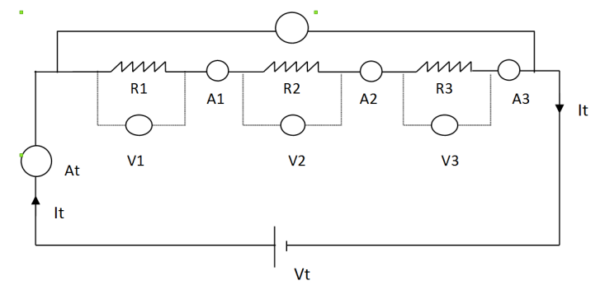
2.1 Series Combination of Resistors
Figure 1. Resistors in series form

The resistors are said to be connected in series if the sum of the potential differences across each is equal to potential difference, $V_{t}$ of supply.
The currents pass through each resistor are equal with $I_{t}$ in the circuit.
(1)
$$I_{t}=I_{1}=I_{2}=I_{3}$$
(2)
$$I_{t}=\frac{V_{t}}{R_{1}+R_{2}+R_{3}}$$
For the equivalent resistance
(3)
$$R_{eq}=R_{1}+R_{2}+R_{3}$$

The extension to n resistors is straightforward
(4)
$$R_{eq}=ΣR_{n}$$
The potential difference $V_{t}$ is equal to the sum of the potential differences of each resistor
(5)
$$V_{t}=V_{1}+V_{2}+V_{3}$$
Equation (2) can be rewritten by the substitution of equation (3)
(6)
$$I_{t}=\frac{V_{t}}{R_{eq}}$$
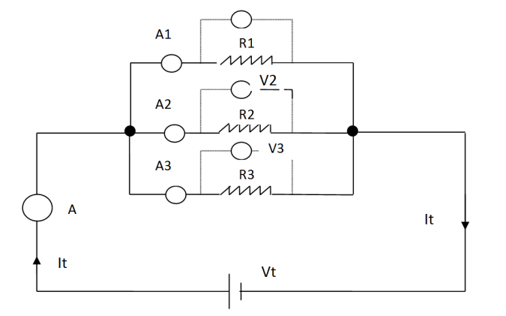
2.2 Parallel Combination of Resistors
Figure 2. Resistors in parallel form

The currents in the three branches of Figure 2 are:
(8)
(7)
$$I_{1}=\frac{V_{1}}{R_{1}}$$
$$I_{2}=\frac{V_{2}}{R_{2}}$$
$$I_{3}=\frac{V_{3}}{R_{3}}$$
(9)
The potential difference on each branch are equal to each other:
(10)
$$V_{t}=V_{1}=V_{2}=V_{3}$$

Total current $I_{t}$ on the main branch is equal to the sum of the currents on each branch
(11)
$$I_{t}=I_{1}=I_{2}=I_{3}$$
(12)
$$\frac{1}{R_{eq}}=\frac{1}{R_{1}}+\frac{1}{R_{2}}+\frac{1}{R_{3}}$$

The equivalent resistance, $R_{eq}$
Extending this result to the case of n resistors, we find:
(13)
$$\frac{1}{R_{eq}}=Σ\frac{1}{R_{n}}$$

2.3 Series and Parallel Combination of Resistors
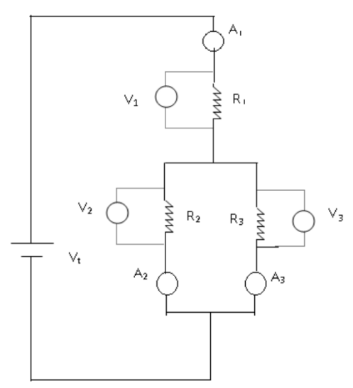

Figure 3. Resistors in combination of parallel and serial form

3. Experimental Setup
3.1 Equipment List

1. Board x1
2. Dc voltage source x1
3. Digital multimeter x2
4. Connection cables 40cm x3
5. Connection cables 25cm x4
6. Connection cables 15cm x5
7. Resistors x3

4. Conclusion
In this experiment, we learned to measure resistors’ voltage using voltmeter and we learned serial and parallel combination. We found the values ​​of the voltages we measured in parallel connected resistors equal, but in series connected resistors, the voltages are measured in direct proportion to their resistances.

Table 1: Measured voltage, current and resistor values
Figure (1) | $$V_{1}: 2.79 V$$ | $$V_{2}:1.08 V$$ | $$V_{3}: 1.11 V$$
Figure (1) | $$R_{1}:5.49 KΩ$$ | $$R_{2}:2.16 KΩ$$ | $$R_{1}:2.15 KΩ$$
Figure (1) | $$I_{1}: 0.5 A$$ | $$I_{2}: 0.5 A$$ | $$I_{3}:0.516 A$$
Equivalent Resistance 1: 2.8 $KΩ$
Figure (2) | $$V_{1}: 5 V$$ | $$V_{2}:5 V$$ | $$V_{3}: 5 V$$
Figure (2) | $$R_{1}:5.49 KΩ$$ | $$R_{2}:2.16 KΩ$$ | $$R_{1}:2.15 KΩ$$
Figure (2) | $$I_{1}: 0.91 A$$ | $$I_{2}: 2.315 A$$ | $$I_{3}:2.325 A$$
Equivalent Resistance 1: 0.9 $KΩ$
Figure (3) | $$V_{1}: 5 V$$ | $$V_{2}:5 V$$ | $$V_{3}: 1.11 V$$
Figure (3) | $$R_{1}:5.49 KΩ$$ | $$R_{2}:2.16 KΩ$$ | $$R_{1}:2.15 KΩ$$
Figure (3) | $$I_{1}:0.91 A$$ | $$I_{2}:2.315 A$$ | $$I_{3}:0.516 A$$
Equivalent Resistance 1: 1.9 $KΩ$

